**Biology STAAR Review Stations**

**Day 3**

**Category #1 Cell Structure and Processes (9.A, 9.D)**

9.A compare the structures and functions of different types of biomolecules including carbohydrates, lipids, proteins, and nucleic acids;

9.D analyze and evaluate the evidence regarding formation of simple organic molecules and their organization into long complex molecules having information such as the DNA molecule for self-replicating life.

**9.A, 9.D Pre-Test Score__________ Focus TEKS__________**

|  |  |  |
| --- | --- | --- |
|  | **9.A** | **9.D** |
| **Interactive Quizzes** | **Biological Macromolecules Interactive Table**  <http://glencoe.mcgraw-hill.com/olcweb/cgi/pluginpop.cgi?it=swf::550::400::/sites/dl/free/0078695104/383912/table6_1.swf::Biological%20Macromolecules>  **Score_______**  **Identifying Biomolecules Activity**  Go the following link:  <https://www.msu.edu/~russellr/portfolio/biosci_sm_biomols/macromol_830.html>  **Macromolecule Tutorial**  <http://bcs.whfreeman.com/thelifewire/content/chp03/0302002.html>  Go through the introduction, animation, conclusion and quiz. Record your own quiz results. | **Nucleic Acids: DNA and RNA**  **Reading and Quiz**  <http://www.visionlearning.com/en/library/Biology/2/Nucleic-Acids/63/reading> |
| **Graphic Organizers Organizers** | **Biomolecule Chart**  <https://secure.lcisd.org/schools/HighSchools/FosterHighSchool/Faculty/Science/SharaDluhos/PreAPBiology/1stSixWeeks/images/Biomolecules%20Chart%20Key.pdf> | **Biomolecule Mini-Poster**  **See handout** |
| **Virtual Labs** | **Organic Molecules**  **http://www.occc.edu/biologylabs/Documents/Organic%20Compounds/Organic%20Compounds.htm** | **Miller-Urey Experiment Virtual Lab**  <http://www.projectsharetexas.org/node/10586> |
| **Vocabulary** | **Biomolecule Flashcards**  See handout | |
| **Video Clips** | **Biomolecule Band**  <http://www.youtube.com/watch?v=IJ7xOSCEmZw> | **Biological Molecules**  <http://www.bozemanscience.com/042-biologoical-molecules/> |

**9.A, 9.D Post Test Score__________**

**Notes:**

**9.A, 9.D Critical Thinking Questions**

1. Where can biomolecules be found in living systems and how can they be identified?

2. Describe the structure of bio-molecules and how monomers form polymers.

3. Discuss the importance of biomolecules to proper functioning of living things.

4. Compare the different types of biomolecules; carbohydrates, proteins, lipids and nucleic acids.

**9.A Biomolecule Mini-Poster**

Use the ppt link for assistance:

[**http://tinyurl.com/ppbapuu**](http://tinyurl.com/ppbapuu)

|  |  |  |  |
| --- | --- | --- | --- |
|  | **Elements** | **Monomer** | **Functions** |
| **Nucleic Acid** |  |  |  |
| **Protein** |  |  |  |
| **Lipid** |  |  |  |
| **Carbohydrate** |  |  |  |

**9.A, 9.D Flashcards**

Use the Visionlearning glossary for help:

<http://www.visionlearning.com/en/glossary>

|  |  |  |
| --- | --- | --- |
| **adenosine triphosphate** | **peptide** | **saccharide** |
| **lipid** | **organic compound** | **fatty acid** |
| **monomer** | **polymer** | **nucleic acid** |
| **macromolecule** | **amino acid** | **nucleotide** |
| **phospholipids** | **carbohydrate** | **peptide bond** |
| **protein** |  |  |

**9.D Matching**

|  |  |
| --- | --- |
| **Polymerization** | Linking monomers to form polymers |
| **Condensation Reaction** | Occurs through the loss of a small molecule, resulting in the formation of a bond |
| **Dehydration Reaction** | Limited to condensations with small molecule of water |
| **Hydrolysis** | Catabolic process by which the bonds between molecules are broken by the enzyme by adding water |
| **Catabolism** | Break down molecules to release energy |
| **Anabolism** | Build molecules and require energy |
| **glucose + glucose = maltose + water** | Dehydration synthesis |
| **Sucrose + water = glucose + fructose** | Hydrolysis |

**Day 3 Review Questions 9.A, 9.D**

9.A  
_____1. These molecules are examples of ____.

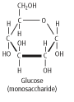

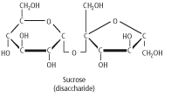

**A)**http://glencoe.mheducation.com/olcweb/styles/shared/spacer.gifenzymeshttp://glencoe.mheducation.com/olcweb/styles/shared/spacer.gif

**B)**http://glencoe.mheducation.com/olcweb/styles/shared/spacer.gifcarbohydrateshttp://glencoe.mheducation.com/olcweb/styles/shared/spacer.gif

**C)**http://glencoe.mheducation.com/olcweb/styles/shared/spacer.gifproteinshttp://glencoe.mheducation.com/olcweb/styles/shared/spacer.gif

**D)**http://glencoe.mheducation.com/olcweb/styles/shared/spacer.gifinorganic substances

9.A  
_____2. Judging from this graph, what are the most abundant elements in living things?

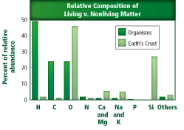

**A)**http://glencoe.mheducation.com/olcweb/styles/shared/spacer.gifnitrogen and calciumhttp://glencoe.mheducation.com/olcweb/styles/shared/spacer.gif

**B)**http://glencoe.mheducation.com/olcweb/styles/shared/spacer.gifhydrogen, carbon, oxygenhttp://glencoe.mheducation.com/olcweb/styles/shared/spacer.gif

**C)**http://glencoe.mheducation.com/olcweb/styles/shared/spacer.gifcarbon, sodium, potassiumhttp://glencoe.mheducation.com/olcweb/styles/shared/spacer.gif

**D)**http://glencoe.mheducation.com/olcweb/styles/shared/spacer.gifoxygen and sodium

9.A

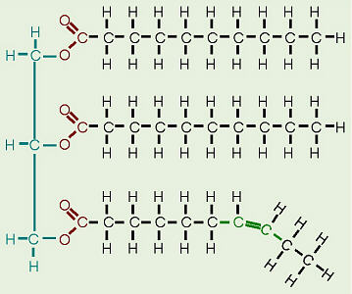_____3. The diagram to the right represents which of the following **biomolecules**?

a. carbohydrate

b. protein

c. lipid

d. nucleic acid

9.A

**Nitrogen (N) is used and reused by various organisms and processes as it cycles through the environment.**

_____4. Study the statement above. Nitrogen is NOT a part of which of these biomolecules?

a. enzyme

b. amino acid

c. nucleic acid

d. carbohydrates

9.A

_____5. Study the statement above. Why is nitrogen important to living things?

a. Nitrogen is a key component of all carbohydrates.

b. Nitrogen is a key component of proteins.

c. Nitrogen is a key component of cellulose.

d. Nitrogen is a key component of lipids.

9.A

_____6. Certain types of biomolecules are crucial to a variety of life processes and body structures. One of these types of molecules are **proteins**, which are-

a. composed of building blocks called amino acids

b. insoluble in water and are used by the body for energy storage and insulation

c. complex biomolecules that store genetic information

d. organic compounds used by cells to store and release energy

9.D

_____7. A process by which bonds between monomers are broken by an enzyme and the addition of water:

1. synthesis
2. hydrolysis
3. condensation
4. photosynthesis

9.D

_____8. A process by which two molecules are chemically bonded through the use of enzymes and a loss of water. As illustrated in the below diagram:

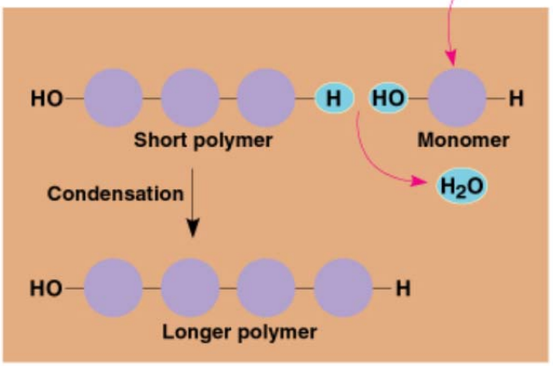

1. protein synthesis
2. respiration
3. dehydration synthesis
4. photosynthesis

9.D

_____9. What did the following experiment suggest?

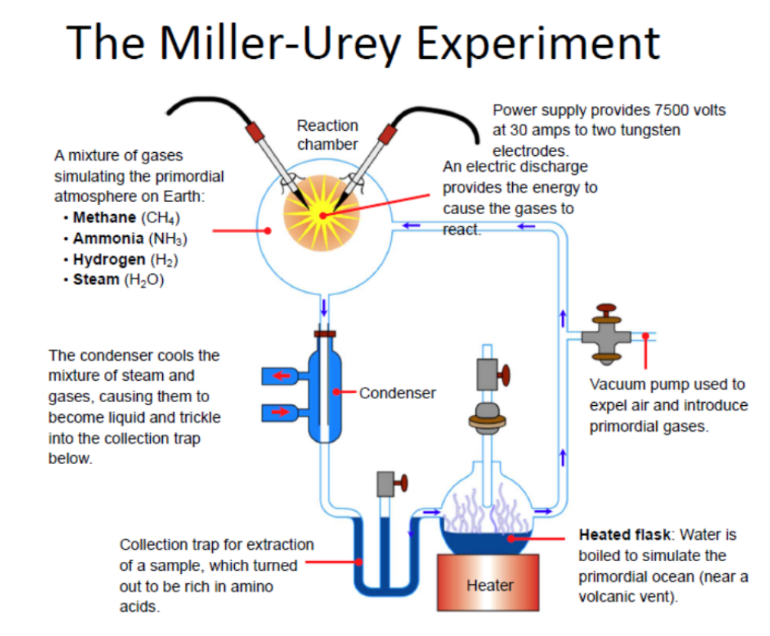

a. simple chains of organic molecules could be created in conditions similar to early Earth

b. this experiment made it possible to form all of the 20 amino acids commonly found in all organisms

c. by replicating early Earth conditions, the chemicals essential for life were produced

d. all of the above

9.D

_____10. **Specific biomolecules serve various functions in the body.** Identify the molecule which contains the instructions used to create an organism’s enzymes and proteins.

1. a. nicotinamide adenine dinucleotide (NAD+)
2. b. hemoglobin
3. c. deoxyribonucleic acid (DNA)
4. d. glucose

**Day Three Review Questions (9.A, 9.D)**

**Answer Sheet**

**_____1.**

**_____2.**

**_____3.**

**_____4.**

**_____5.**

**_____6.**

**9.A Score__________/6**

**_____7.**

**_____8.**

**_____9.**

**_____10.**

**9.B Score_________/4**

**Day Three Review Questions (9.A, 9.D)**

**Key**

**__**B__**1.**

**__B__2.**

**__C__3.**

**__D__4.**

**__B__5.**

**__A__6.**

**__B__7.**

**__C__8.**

**__D__9.**

**__C__10.**